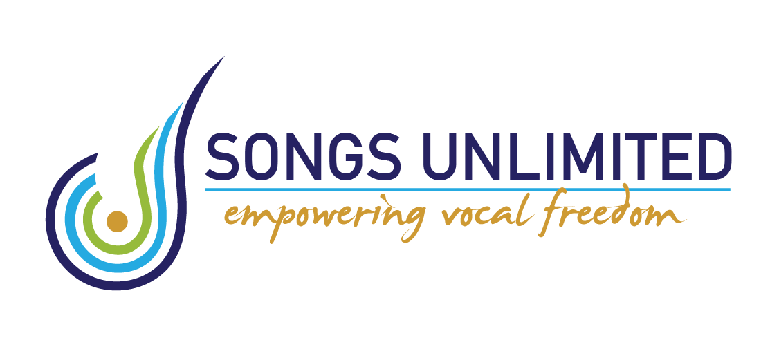
Studio
9 Norwich Ave
Spotswood
New Plymouth
022 320 8607
2024 Singing Year
Ki ora and welcome,

My name is Alyssa Poole and I will be your singing teacher for the year.

I have over 40 years of singing experience and have been teaching for nearly 30 of those years. I have sung in many styles over those years and performed in many shows, a highlight being Earth Mother in the 2020 professional touring company of Menopause the Musical. Currently I am in a singing duo called Two Fat Ladies.

Here are some things that you need to know to get the best out of our time together:

Please treat: me, my time, yourself and the ones paying for your lessons with respect by:

*Turning up to lessons on time…so that we can maximise our time together and get straight into learning. Consider warming up beforehand (or at least in the car) so that your focus is ready to go. If you decide that continuing lessons are not for you then let me know asap as there is a waiting list of those who want lessons.

*Practise at home…you won’t improve if you just come to a lesson once a week and don't practise what you have learned. Take the time to put into practice the discoveries that we make together and see how it works for you.

*Use downtime and activities that don’t require much brain space like chores or waiting times or car trips to sing or at least think about singing and learning new songs.

*Please ASK…if you don't understand something…there are many ways to explain, and it’s my job to try and find different ways to empower your journey into vocal freedom and help you understand your voice.

*Understand that lessons will be learning about your voice, your instrument, how to face fears and grow in confidence. We won’t just be singing songs…you can do that at home.

*Be patient!….All good things come to those who wait (and practise!)

*Please pay for lessons before you arrive. I will send out invoices which have my banking details and policy. All lessons must be paid for and cannot be made up if missed. If you know at least 24 hours in advance that you can’t make it.

I do hope you will enjoy your time with me…I love my job…singing and teaching others to discover their potential is my favourite thing to do.

Please email or text me if you need to ask questions.

Nga mihi,
Alyssa Poole
M: 0223208607
E: songsunlimited@icloud.com

